Purpose

Virtual Panel II is Cryomech provided application that demonstrates different methods of connecting to a Cryomech cryocooler compressor. It produces compressor status as well as providing a means to operate the compressor.

Operation

When the application is first launched, a selection screen is presented for you to choose the means by which you wish to connect to the compressor. If ethernet is selected, there is a textbox provided that allows entering of the compressor’s IP address.

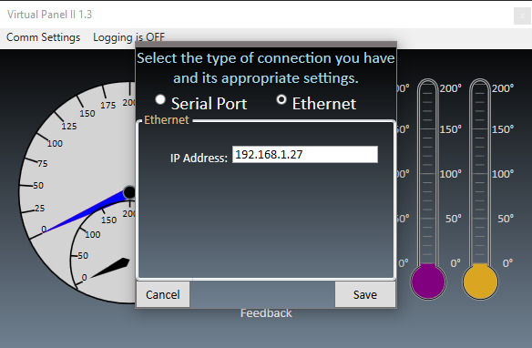

If serial port is selected, there are means provided for selecting the correct comm port, along with baud rate and compressor ID. An extra option for serial port settings is the possible use of SMDP. This is a legacy protocol that was originally provided with CP model compressors and is still supported in CPA model compressors as a backwards compatibility feature.  
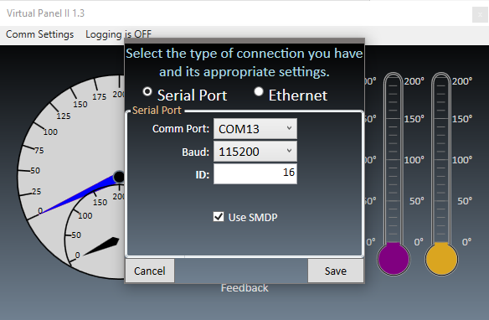

After selecting the communications method and saving, the screen will look like this.

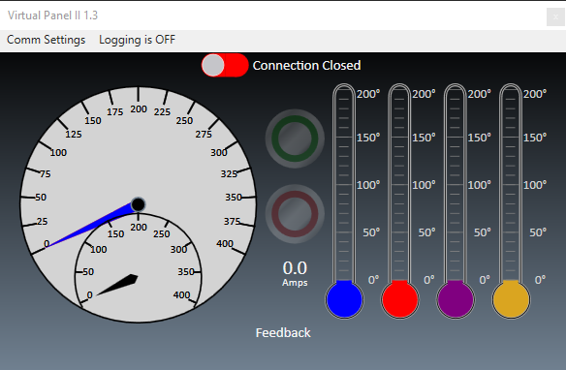

Clicking on the switch at the top of the screen will tell the application to attempt a connection. When it has succeeded it will look something like one of the following two screens depending on the compressor’s state. Note the example running screen also shows how warning and errors will be displayed.

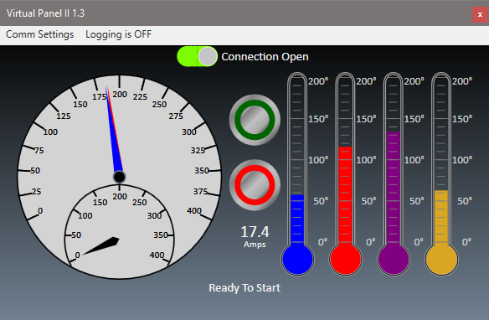 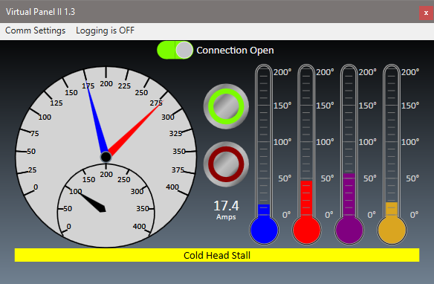

Logging Feature

Virtual Panel II provides a logging feature. If you wish to record the compressor’s performance over time, you can activate this feature. By default it will record to the desktop and record once every 15 seconds.

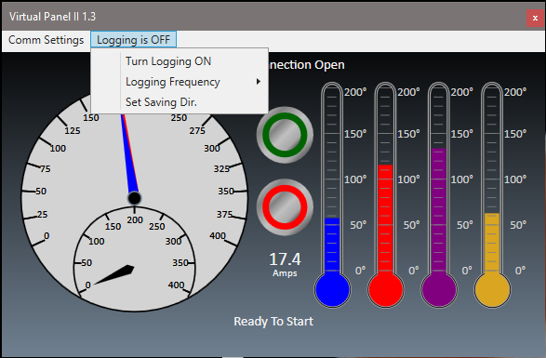

Connection Information

Ethernet:

CPA compressors by default use DHCP to have IP Addresses assigned to them. If you are attempting to connect an ethernet cable directly to a compressor from a computer, you will need to use a crossover cable and you will need to set static IP Addresses on both the compressor and the connected computer. Contact Cryomech service for instructions on how to set a static IP on a compressor. Consult your local IT professional for assigning a static IP to your computer.

Serial Port:

When connecting to the compressor using RS-232, you will need to use a null modem cable.